Rearrangement-Oriented Dissection

Definition
# Source: AI Source: Provided by: [Data Path: Persons Table -> ID Column: 1, Name_En Column: Motasem Essam] -> From: [ChatGPT] on [7/25/2026]
Rearrangement-Oriented Dissection is a geometric dissection method in which a figure is divided into smaller pieces specifically so that those pieces can be rearranged to form another figure or a different arrangement.
The main goal is usually to demonstrate area equivalence, construct a target shape, simplify an area calculation, or solve a geometric puzzle. The pieces are generally moved, rotated, or reflected without stretching or distorting them.
Simple definition: Rearrangement-oriented dissection is cutting a figure into pieces and rearranging those pieces to form another figure.
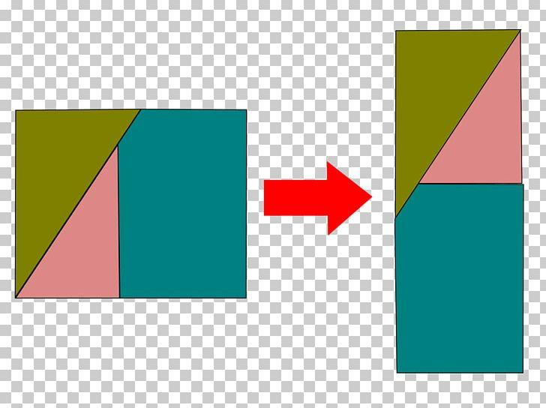
Important distinction: Rearrangement-oriented dissection describes the purpose of the dissection rather than only the shapes of its pieces. It can overlap with triangular, rectangular, polygonal, circular, mixed-shape, and irregular-piece dissection. The categories below are a practical classification, not a universally standardized taxonomy.

Main Classification

1. Area-Equivalence Rearrangement Dissection
# Source: AI Source: Provided by: [Data Path: Persons Table -> ID Column: 1, Name_En Column: Motasem Essam] -> From: [ChatGPT] on [7/25/2026]
Pieces are rearranged to demonstrate that two figures have equal areas.
Example: Rearranging pieces of a polygon to form a rectangle with the same total area.
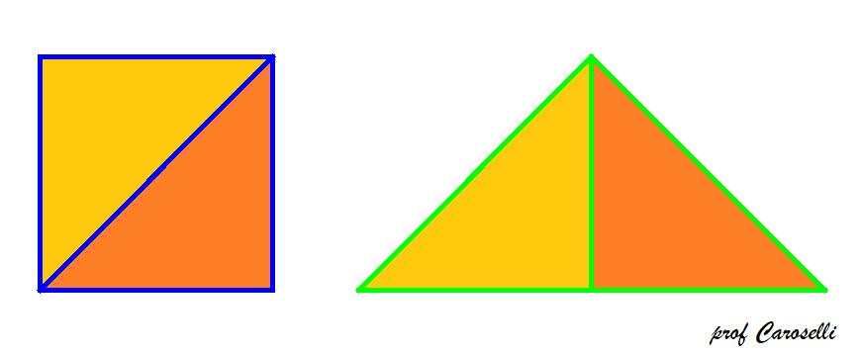
Detailed Mathematical Examples
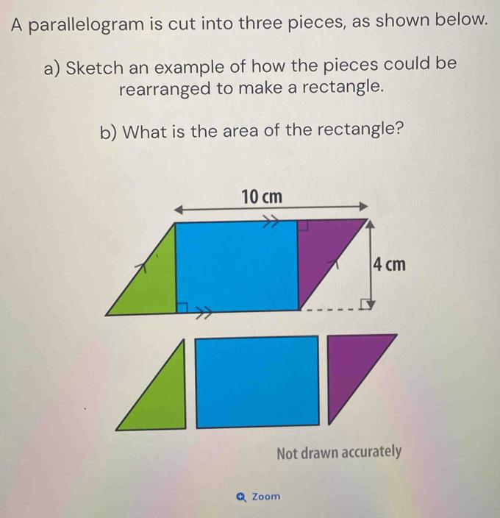
Suppose a figure is divided into three pieces with areas $8$, $12$, and $16$ square units.
The total area is
$$A=8+12+16=36$$
If the pieces can be rearranged into a rectangle of length $9$ and width $4$, its area is
$$A=9×4=36$$
Both figures have the same area. The rearrangement is valid only if the actual pieces fit together to form the rectangle.

2. Square-to-Rectangle Rearrangement Dissection
# Source: AI Source: Provided by: [Data Path: Persons Table -> ID Column: 1, Name_En Column: Motasem Essam] -> From: [ChatGPT] on [7/25/2026]
A square is dissected and its pieces are rearranged to form a rectangle.
Example: Dividing a square into strips and arranging them into a rectangle.
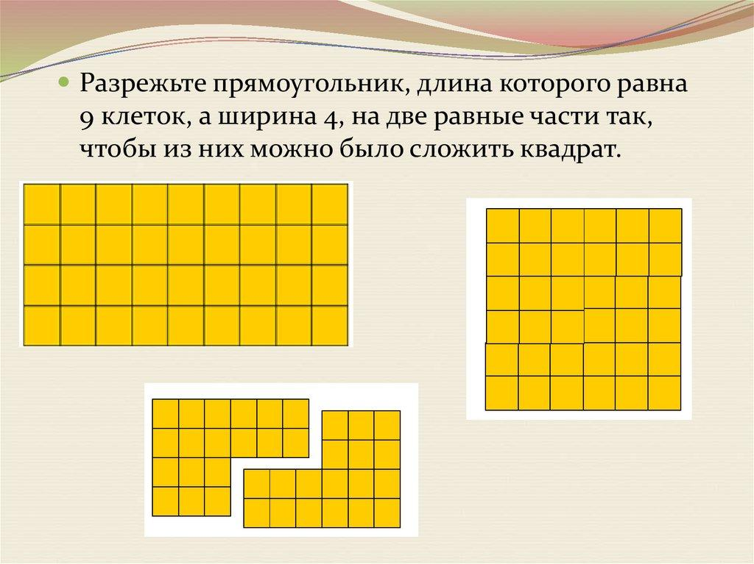
Detailed Mathematical Examples
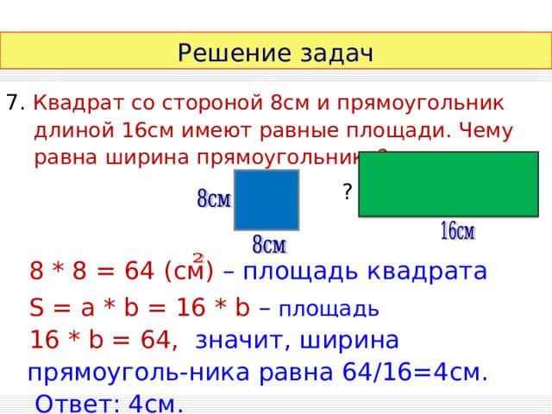
Consider a square with side length $8$.
Its area is
$$A=8^{2}=64$$
Divide it into four strips, each measuring $8×2$. Rearrange these strips to form a rectangle measuring $16×4$.
$$A=16×4=64$$
The square and rectangle have equal areas, even though their dimensions and shapes differ.

3. Rectangle-to-Square Rearrangement Dissection
# Source: AI Source: Provided by: [Data Path: Persons Table -> ID Column: 1, Name_En Column: Motasem Essam] -> From: [ChatGPT] on [7/25/2026]
A rectangle is divided into pieces that can be rearranged to form a square.
Example: Using a suitable set of triangular and polygonal pieces to convert a rectangle into an equal-area square.
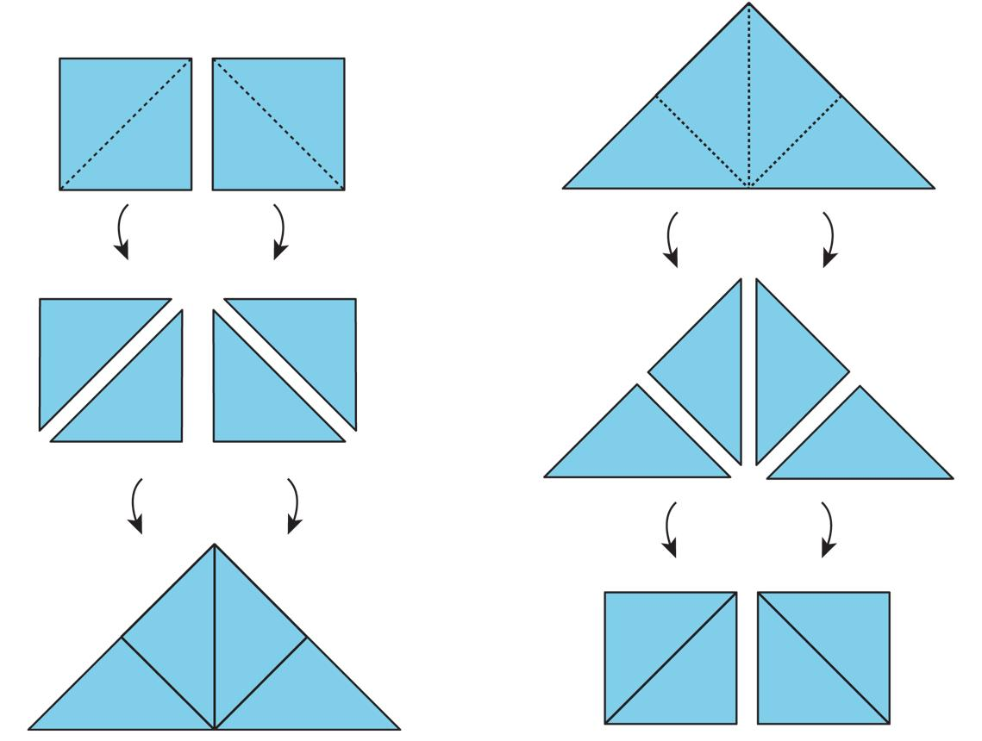
Detailed Mathematical Examples
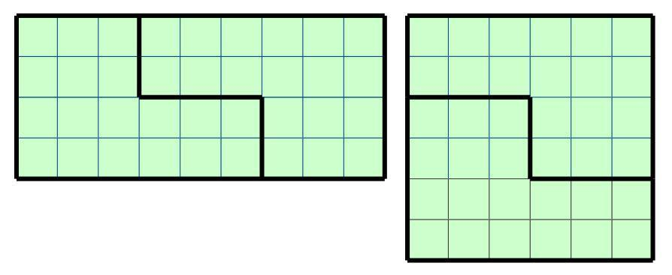
Consider a rectangle measuring $8×2$.
$$A=8×2=16$$
Cut it into two $4×2$ rectangles and place one above the other. The resulting figure is a square measuring $4×4$.
$$A=4×4=16$$
This is a simple example of transforming a rectangle into an equal-area square by rearranging its pieces.

4. Triangle-Based Rearrangement Dissection
# Source: AI Source: Provided by: [Data Path: Persons Table -> ID Column: 1, Name_En Column: Motasem Essam] -> From: [ChatGPT] on [7/25/2026]
Triangles are rearranged to form another triangle or a different polygon.
Example: Two congruent right triangles with legs $3$ and $4$ form a $3×4$ rectangle when joined along their hypotenuses.
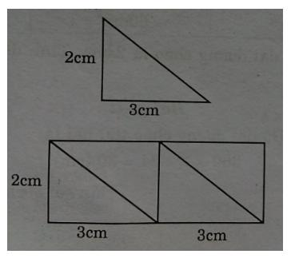
Detailed Mathematical Examples
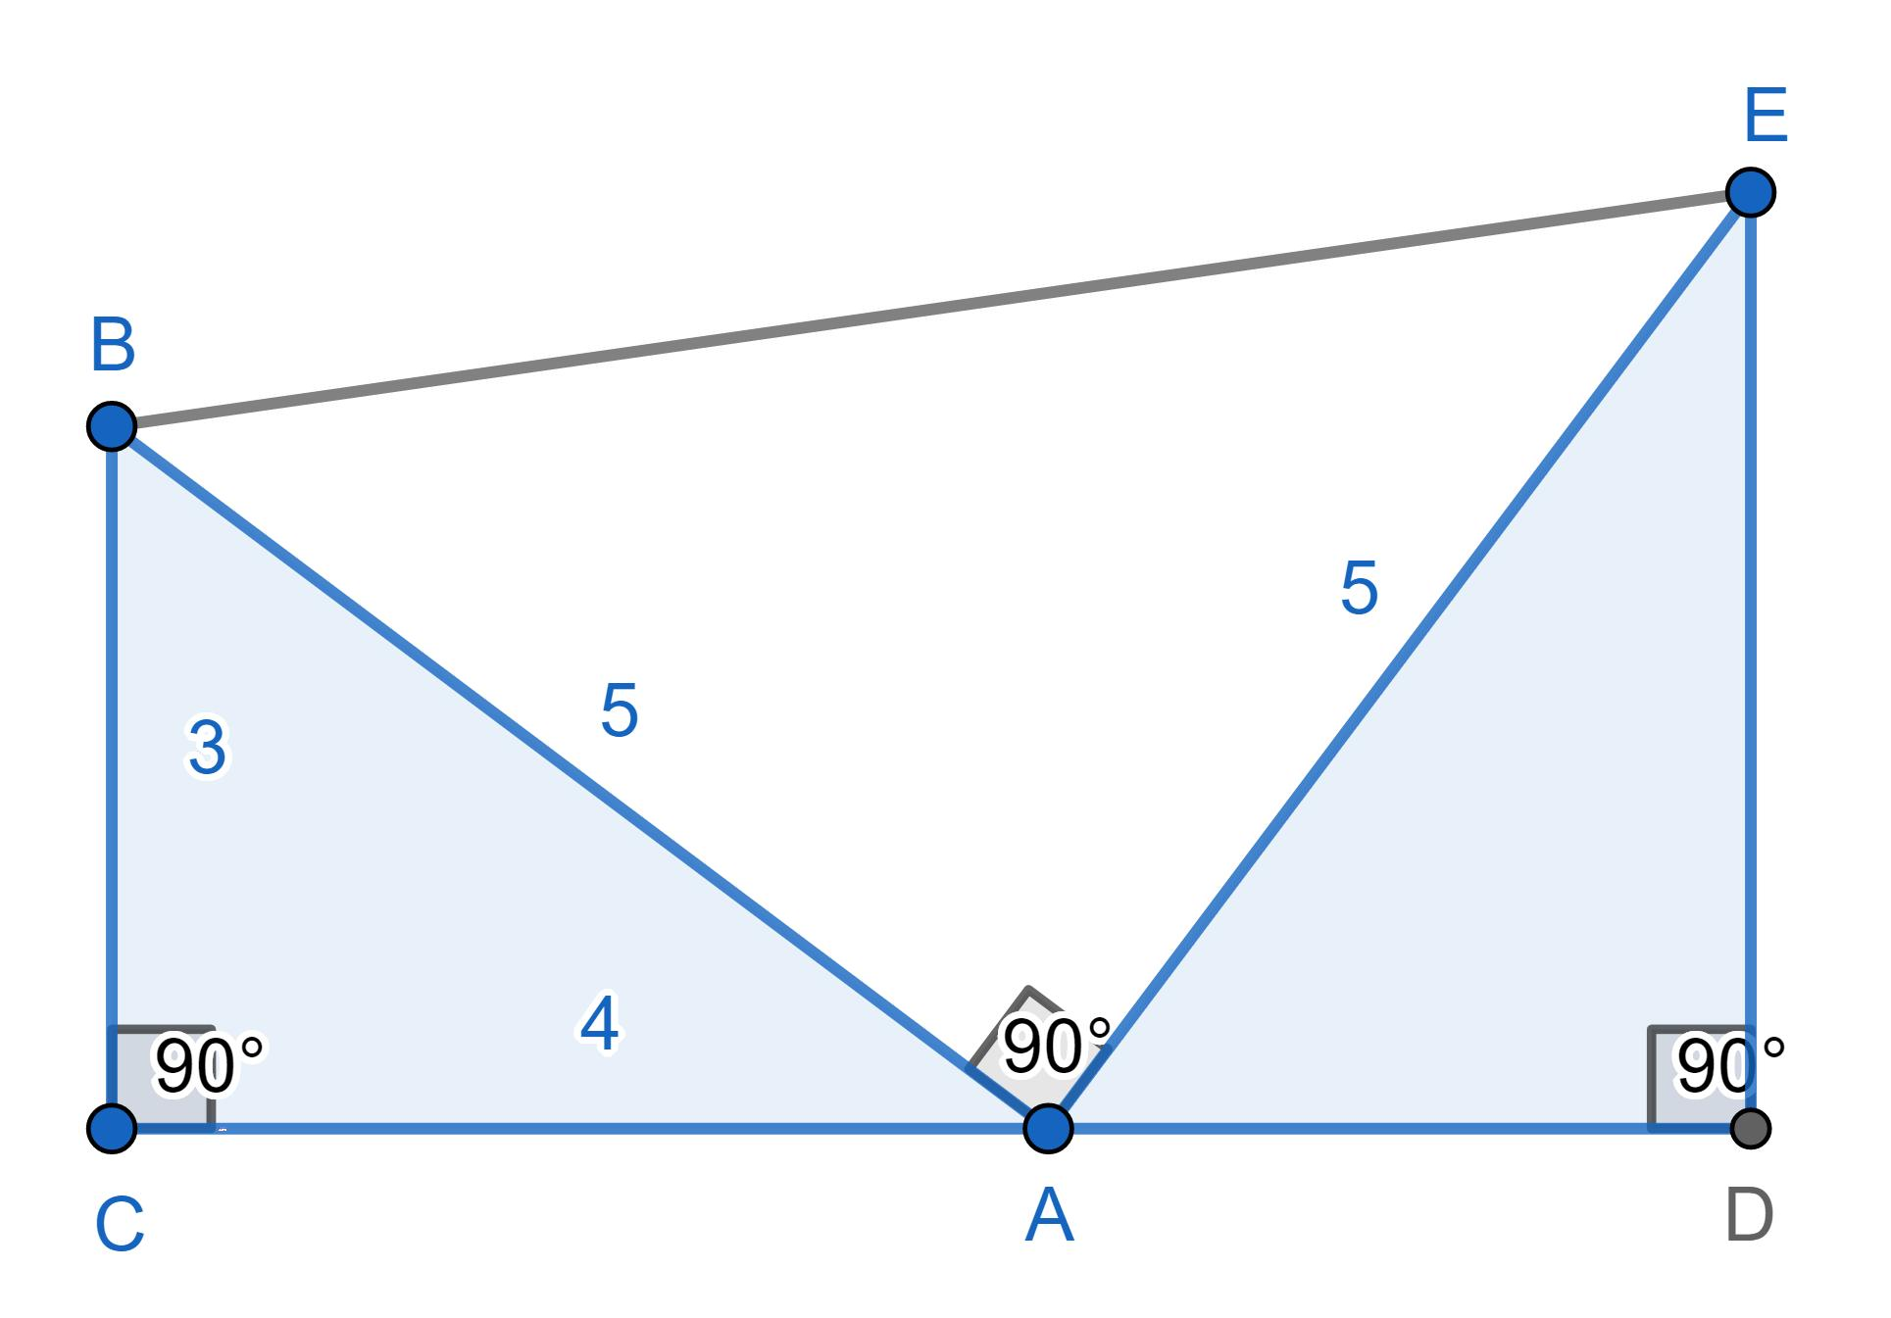
A right triangle with perpendicular sides $3$ and $4$ has area
$$A=\frac{1}{2}\left(3\right)\left(4\right)=6$$
Two congruent copies have total area
$$A_{\text{total}}=2\left(6\right)=12$$
When arranged appropriately, the two triangles can form a $3×4$ rectangle.
$$A_{\text{rectangle}}=3×4=12$$
This works because the pieces are congruent right triangles and can be arranged to reproduce the rectangle's diagonal division in reverse.

5. Polygon-to-Polygon Rearrangement Dissection
# Source: AI Source: Provided by: [Data Path: Persons Table -> ID Column: 1, Name_En Column: Motasem Essam] -> From: [ChatGPT] on [7/25/2026]
Polygonal pieces are rearranged to transform one polygon into another.
Example: Rearranging pieces of a pentagon to create a rectangle of equal area.
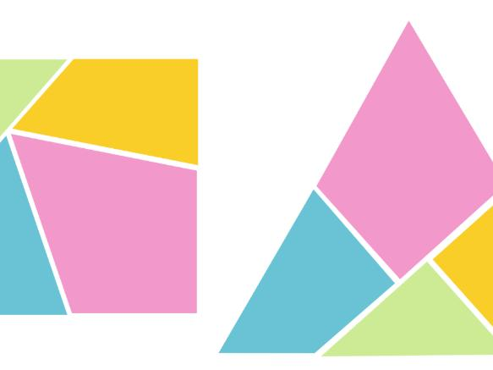
Detailed Mathematical Examples
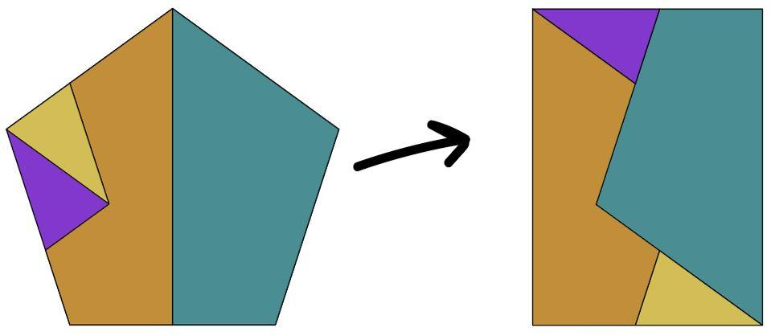
Suppose a polygon is divided into four pieces with areas $5$, $7$, $8$, and $10$ square units.
$$A_{\text{original}}=5+7+8+10=30$$
If these pieces can be rearranged to form a rectangle measuring $6×5$, then
$$A_{\text{rectangle}}=6×5=30$$
The calculation confirms equal area. A complete geometric solution must also show that the pieces fit the target rectangle without gaps or overlaps.

6. Circular Rearrangement Dissection
# Source: AI Source: Provided by: [Data Path: Persons Table -> ID Column: 1, Name_En Column: Motasem Essam] -> From: [ChatGPT] on [7/25/2026]
Circular pieces, such as sectors or segments, are rearranged to form another shape or approximate one.
Example: Alternating many narrow sectors of a disk to produce an approximately rectangular shape.
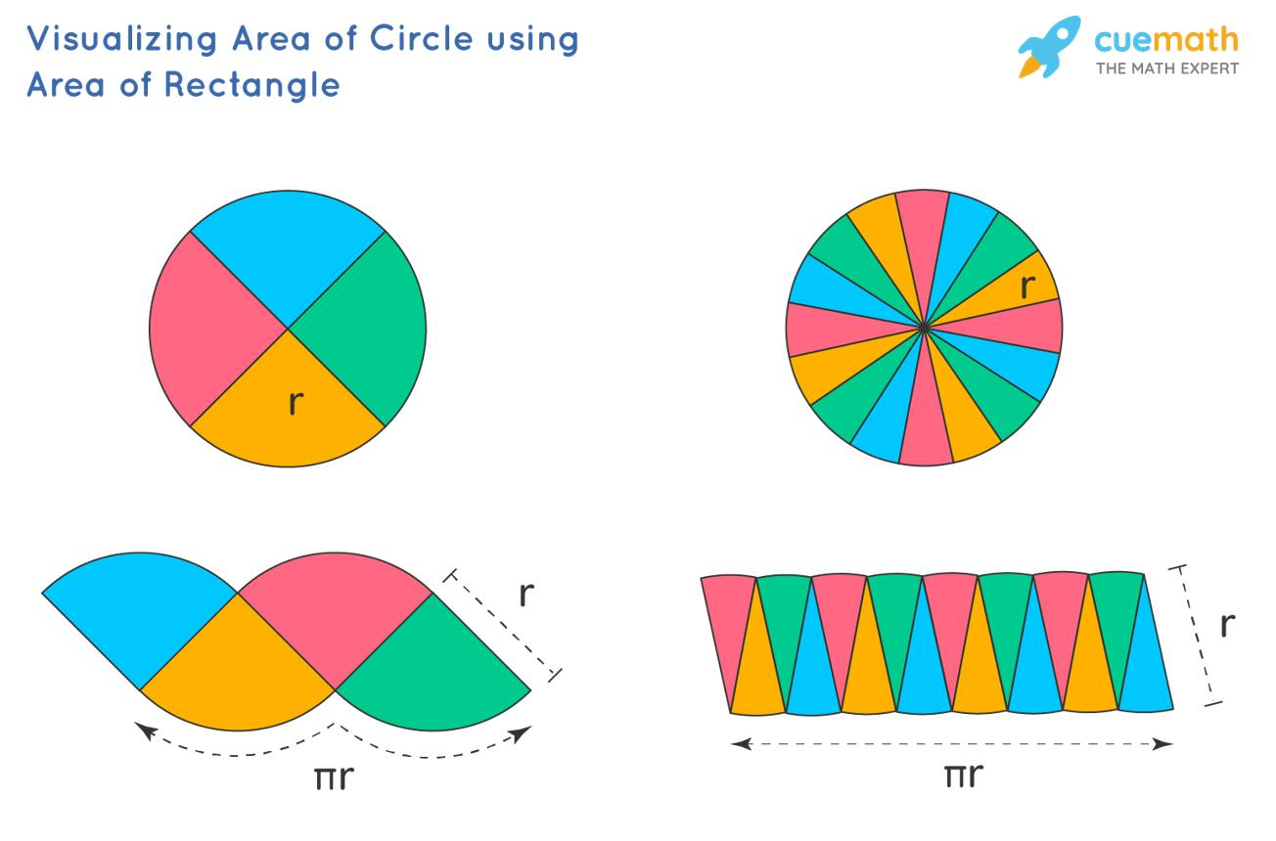
Detailed Mathematical Examples
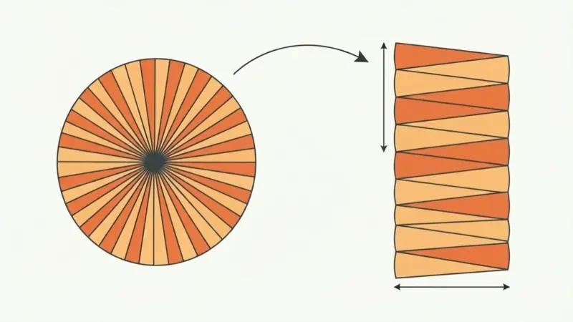
A circle of radius $r$ has area
$$A=πr^{2}$$
Cut the circle into many narrow sectors and arrange them alternately, with one sector pointing upward and the next downward.
As the number of sectors increases, the resulting shape approaches a rectangle or parallelogram-like region with approximate base $πr$ and height $r$.
Its limiting area is
$$A≈\left(πr\right)r=πr^{2}$$
This is a classic rearrangement-based explanation of the circle-area formula. With a finite number of sectors, the outer boundary remains jagged rather than being a perfect rectangle.

7. Irregular-Piece Rearrangement Dissection
# Source: AI Source: Provided by: [Data Path: Persons Table -> ID Column: 1, Name_En Column: Motasem Essam] -> From: [ChatGPT] on [7/25/2026]
Irregular pieces are moved and reassembled into a more convenient shape.
Example: Rearranging irregular polygonal pieces to form a rectangle or another polygon.
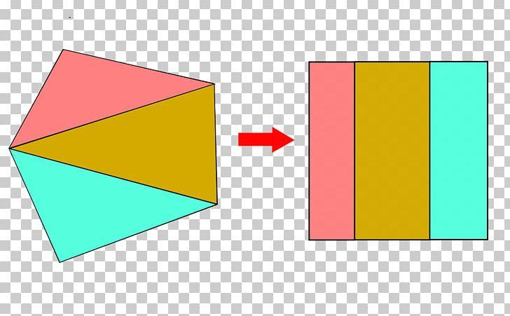
Detailed Mathematical Examples
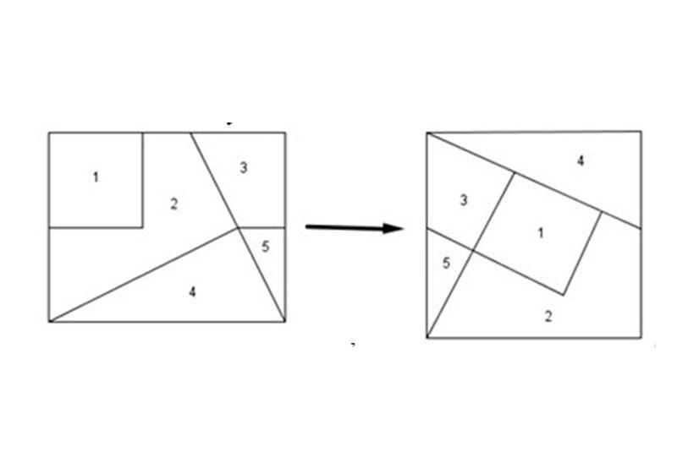
Suppose an irregular figure consists of pieces with areas $9$, $11$, and $16$ square units.
$$A_{\text{total}}=9+11+16=36$$
If the pieces can be assembled into a $6×6$ square, then
$$A_{\text{square}}=6^{2}=36$$
Irregular pieces can be useful for area-equivalence puzzles, but their shapes and edge lengths must permit the proposed arrangement.

8. Rotation-and-Reflection Rearrangement Dissection
# Source: AI Source: Provided by: [Data Path: Persons Table -> ID Column: 1, Name_En Column: Motasem Essam] -> From: [ChatGPT] on [7/25/2026]
Pieces are rotated or reflected to make their edges fit together in a new arrangement.
Example: Turning triangular pieces over or rotating them to assemble a larger polygon.
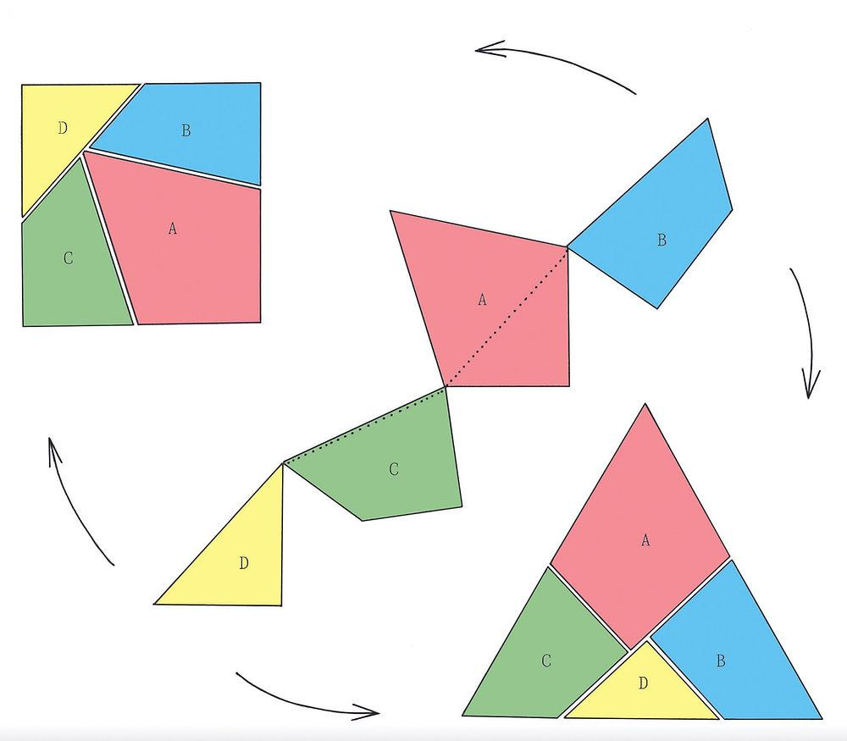
Detailed Mathematical Examples
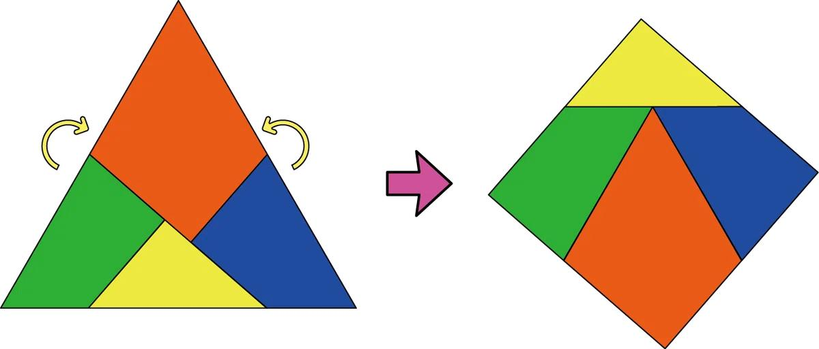
Suppose a dissection produces four congruent triangles, each with area $6$ square units.
$$A_{\text{total}}=4×6=24$$
The triangles may be rotated or reflected to create a larger polygon. Rotation and reflection preserve lengths, angles, and area, so the total area remains $24$ square units.
Not every set of pieces can form every target shape; the arrangement must be geometrically possible.

9. Multiple-Target Rearrangement Dissection
# Source: AI Source: Provided by: [Data Path: Persons Table -> ID Column: 1, Name_En Column: Motasem Essam] -> From: [ChatGPT] on [7/25/2026]
A single dissection is designed so that its pieces can form more than one target figure.
Example: The same set of pieces can form two different polygons, each with the same total area.
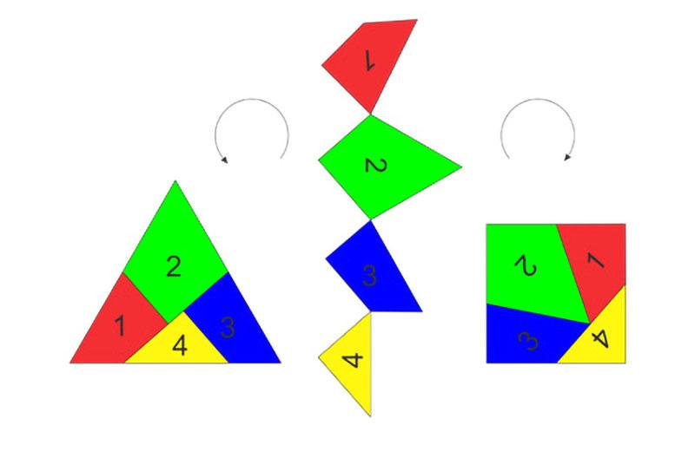
Detailed Mathematical Examples

Suppose a set of pieces has a combined area of $40$ square units.
If the pieces can form both a rectangle and a different polygon, then
$$A_{1}=A_{2}=40$$
The two target figures must have equal areas because they use the same pieces without distortion or overlap. Their perimeters and outlines may differ.

10. Multi-Stage Rearrangement Dissection
# Source: AI Source: Provided by: [Data Path: Persons Table -> ID Column: 1, Name_En Column: Motasem Essam] -> From: [ChatGPT] on [7/25/2026]
Pieces are rearranged through two or more intermediate configurations before reaching the target.
Example: Transforming a complex polygon into a triangle first, then rearranging it into a rectangle.
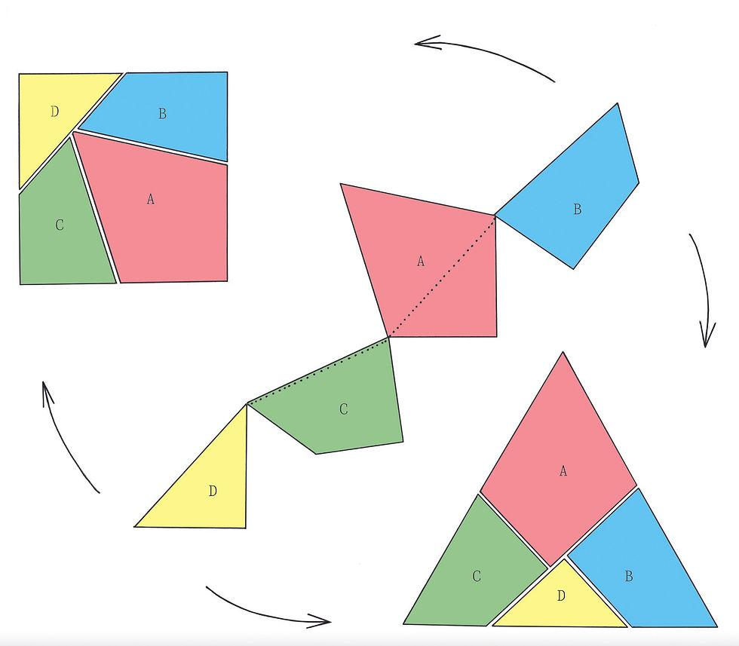
Detailed Mathematical Examples
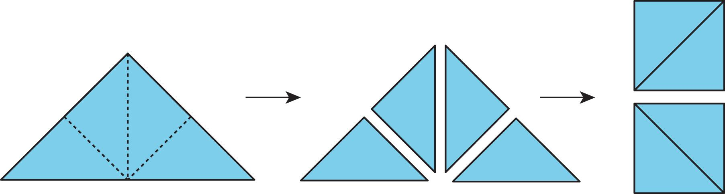
A figure with area $48$ square units may first be dissected into pieces and rearranged into a triangle. The same pieces may then be rearranged into a rectangle measuring $8×6$.
$$A_{\text{triangle}}=48$$
$$A_{\text{rectangle}}=8×6=48$$
The intermediate triangle and final rectangle have equal areas because both are assembled from the same pieces.

11. Shape-Simplification Rearrangement Dissection
# Source: AI Source: Provided by: [Data Path: Persons Table -> ID Column: 1, Name_En Column: Motasem Essam] -> From: [ChatGPT] on [7/25/2026]
A complicated figure is rearranged into a simpler shape to make its properties easier to calculate or prove.
Example: Rearranging a parallelogram into a rectangle to establish the area formula.
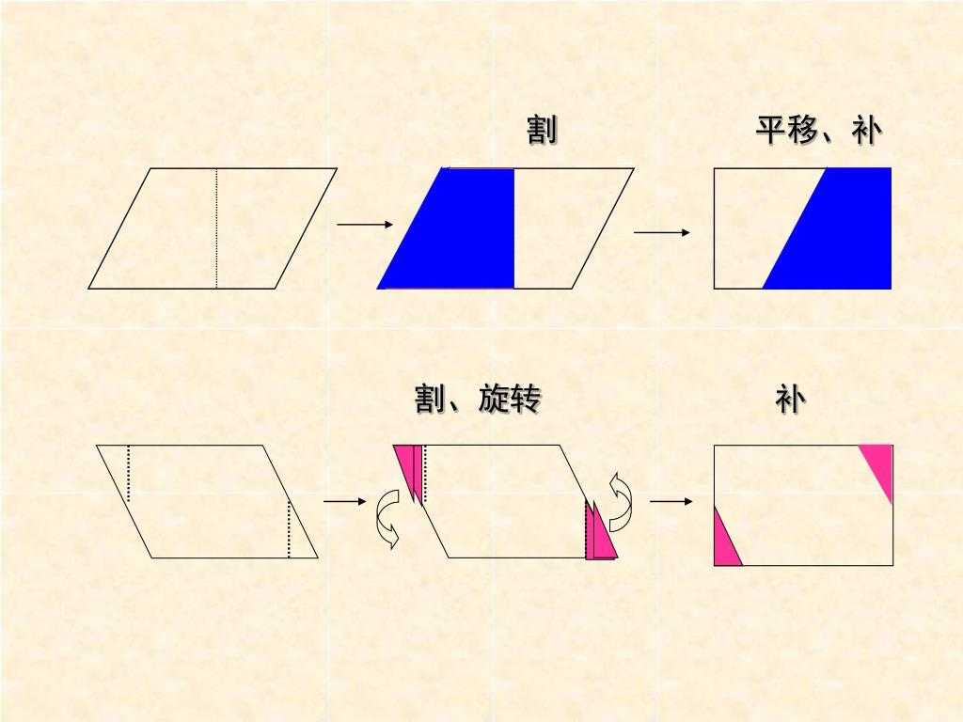
Detailed Mathematical Examples
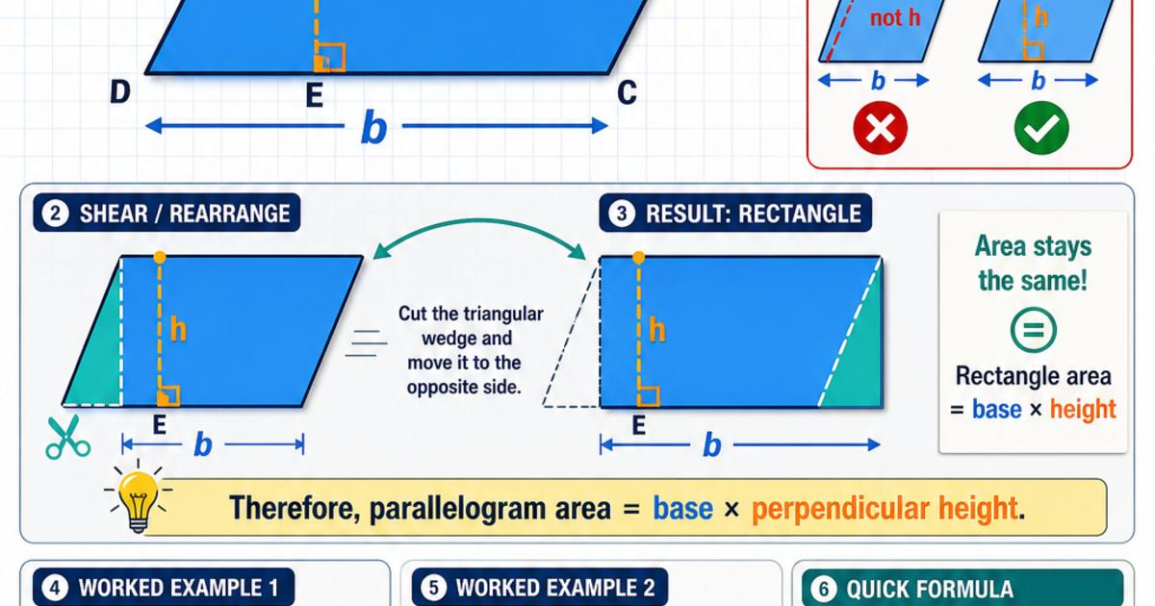
A parallelogram with base $b$ and perpendicular height $h$ can be cut along a suitable perpendicular segment, and a triangular piece can be moved to the opposite side to form a rectangle.
The rectangle has the same base and height, so
$$A_{\text{parallelogram}}=bh$$
and
$$A_{\text{rectangle}}=bh$$
This rearrangement explains why the area of a parallelogram equals its base multiplied by its perpendicular height.

Key Formulas and Principles
# Source: AI Source: Provided by: [Data Path: Persons Table -> ID Column: 1, Name_En Column: Motasem Essam] -> From: [ChatGPT] on [7/25/2026]
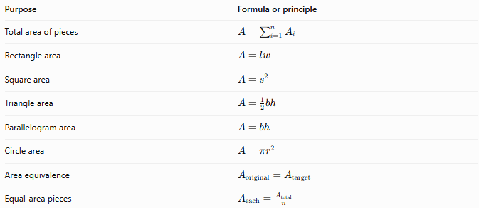
Purpose | Formula or principle
Total area of pieces | $$A=\sum_{i=1}^{n}{A_{i}}$$
Rectangle area | $$A=lw$$
Square area | $$A=s^{2}$$
Triangle area | $$A=\frac{1}{2}bh$$
Parallelogram area | $$A=bh$$
Circle area | $$A=πr^{2}$$
Area equivalence | $$A_{\text{original}}=A_{\text{target}}$$
Equal-area pieces | $$A_{\text{each}}=\frac{A_{\text{total}}}{n}$$
The central principle is area preservation: rearranging pieces without stretching, shrinking, removing, or duplicating them preserves their combined area.

Comparison with Other Dissection Types
# Source: AI Source: Provided by: [Data Path: Persons Table -> ID Column: 1, Name_En Column: Motasem Essam] -> From: [ChatGPT] on [7/25/2026]
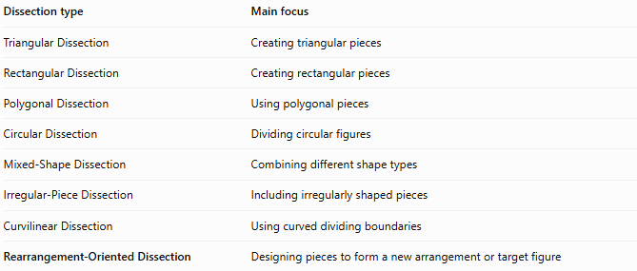
Dissection type | Main focus
Triangular Dissection | Creating triangular pieces
Rectangular Dissection | Creating rectangular pieces
Polygonal Dissection | Using polygonal pieces
Circular Dissection | Dividing circular figures
Mixed-Shape Dissection | Combining different shape types
Irregular-Piece Dissection | Including irregularly shaped pieces
Curvilinear Dissection | Using curved dividing boundaries
Rearrangement-Oriented Dissection | Designing pieces to form a new arrangement or target figure
These classifications describe different aspects of dissection. For example, one problem may simultaneously be triangular, polygonal, and rearrangement-oriented.

Classification Summary
# Source: AI Source: Provided by: [Data Path: Persons Table -> ID Column: 1, Name_En Column: Motasem Essam] -> From: [ChatGPT] on [7/25/2026]
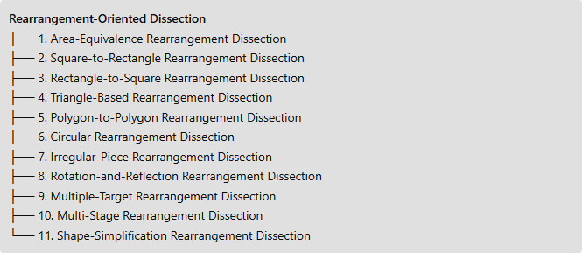
Rearrangement-Oriented Dissection
├── 1. Area-Equivalence Rearrangement Dissection
├── 2. Square-to-Rectangle Rearrangement Dissection
├── 3. Rectangle-to-Square Rearrangement Dissection
├── 4. Triangle-Based Rearrangement Dissection
├── 5. Polygon-to-Polygon Rearrangement Dissection
├── 6. Circular Rearrangement Dissection
├── 7. Irregular-Piece Rearrangement Dissection
├── 8. Rotation-and-Reflection Rearrangement Dissection
├── 9. Multiple-Target Rearrangement Dissection
├── 10. Multi-Stage Rearrangement Dissection
└── 11. Shape-Simplification Rearrangement Dissection

Key Points
# Source: AI Source: Provided by: [Data Path: Persons Table -> ID Column: 1, Name_En Column: Motasem Essam] -> From: [ChatGPT] on [7/25/2026]
- The main objective is to rearrange pieces into another figure or configuration.
- Pieces may be translated, rotated, or reflected without changing their shape or area.
- The original and target figures have equal areas when exactly the same pieces form both figures.
- Equal area alone does not prove that a proposed dissection or rearrangement is possible.
- Some rearrangements are exact; others, such as the circle-sector approximation, approach a target shape only in a limiting process.
- The categories above are practical and may overlap.

Conclusion
# Source: AI Source: Provided by: [Data Path: Persons Table -> ID Column: 1, Name_En Column: Motasem Essam] -> From: [ChatGPT] on [7/25/2026]
Rearrangement-Oriented Dissection focuses on how dissected pieces can be reassembled to create a new geometric figure. It is useful for demonstrating area equivalence, deriving area formulas, solving geometric puzzles, and simplifying complex figures. Its defining feature is the intended rearrangement, not the original figure's shape or the specific types of pieces.

